Set of exercises for the correction of posture defects related to working at the computer.

Gminny Zespół Szkół w Kazimierzu Dolnym

Set of exercises for the correction of posture defects related to working at the computer.

AIMS:
* removal of muscles tension, prevention of contractures
* increased mobility in individual sections of the spine
* improving circulation
* strengthening the muscles responsible for maintaining correct posture

EDUCATIONAL ACCENT:
* shaping the need for self-control
* conscious participation in classes
* implementation to do home exercises

WAYS OF EXERCISING
- We perform the exercises in the form of a circuit
- We perform each exercise in 10 repetitions
- We make from 2 to 4 circuits, with a break of max. 3 minutes between circuits
- We precede the exercises with a short warm-up

MOBILIZATION OF THE NECK SPINE

EXERCISE NO 1:
standing position, hands along the torso, bow your head to the side, an ear to shoulder;
bow your head to the side, a nose to shoulder

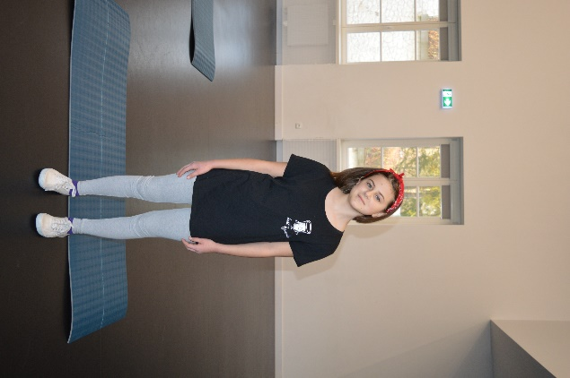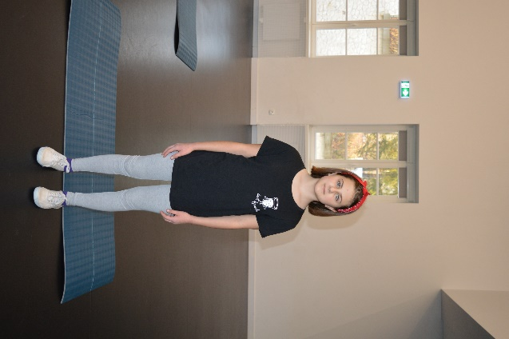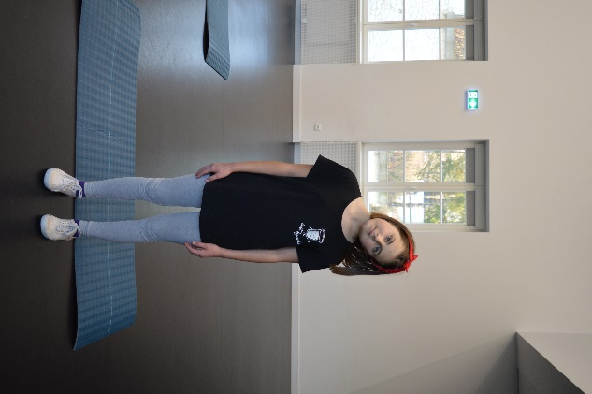

MOBILIZATION OF THE CHEST SECTION

EXERCISE NO 2:

lying sideways, legs bent at the knees, feet parallel, arms/ hands stretched forward, hands joined, abduction of the right hand to the side while turning the head /repeat second side/
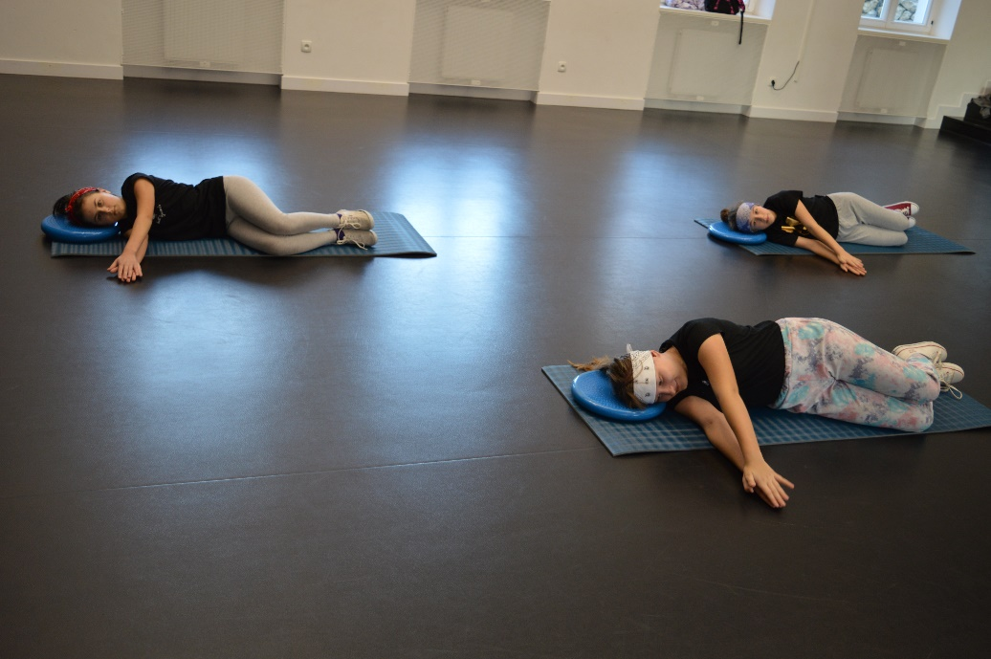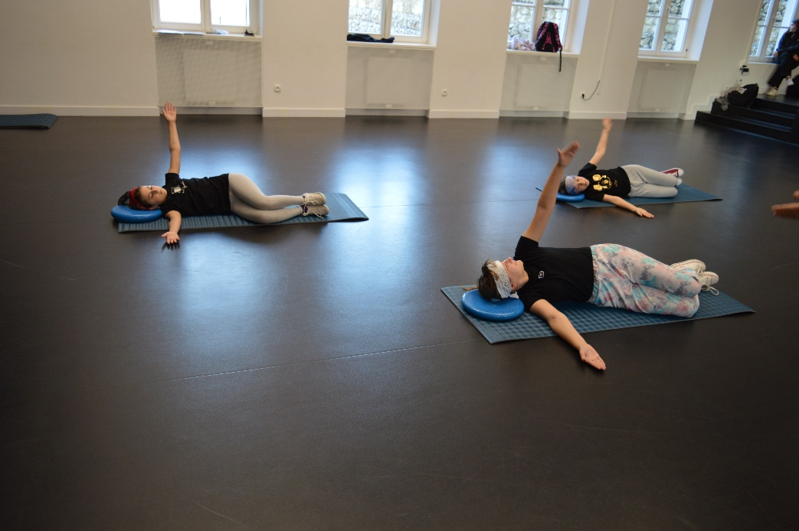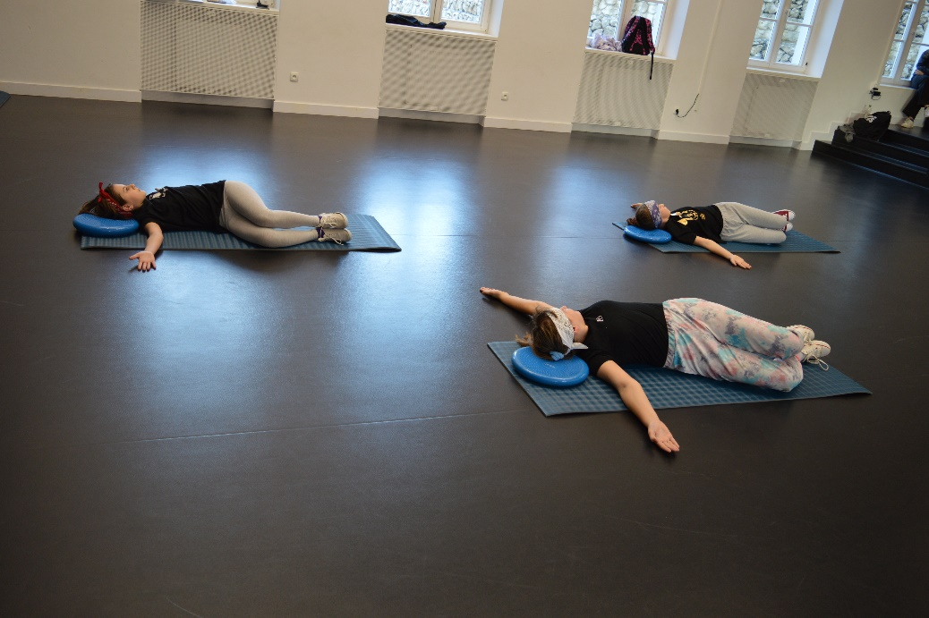

EXERCISE NO 3:

position- propped kneeling, curvature of the spine / back in a bow, head between shoulders/
back to the position
collapse of the spine in the lumbar region, buttocks tense, head up, return to position
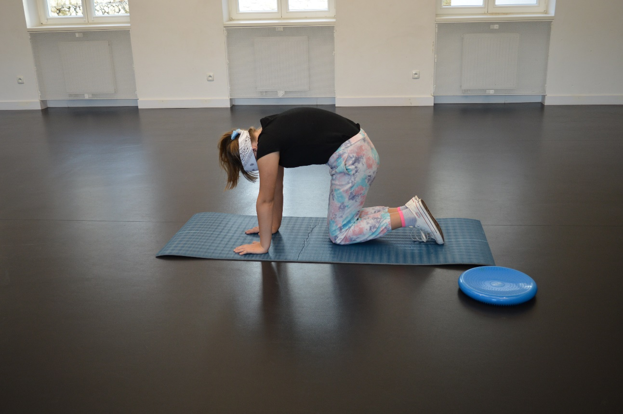
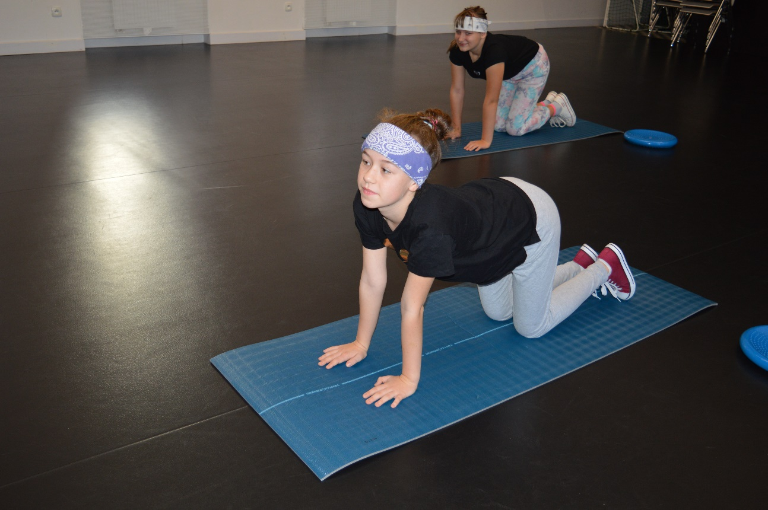
LUMBAR MOBILIZATION

EXERCISE NO 4:

position – propped knelling, sit on your heels, hands forward,
bend the torso as far forward as possible - ‘’ Japanese bow’’

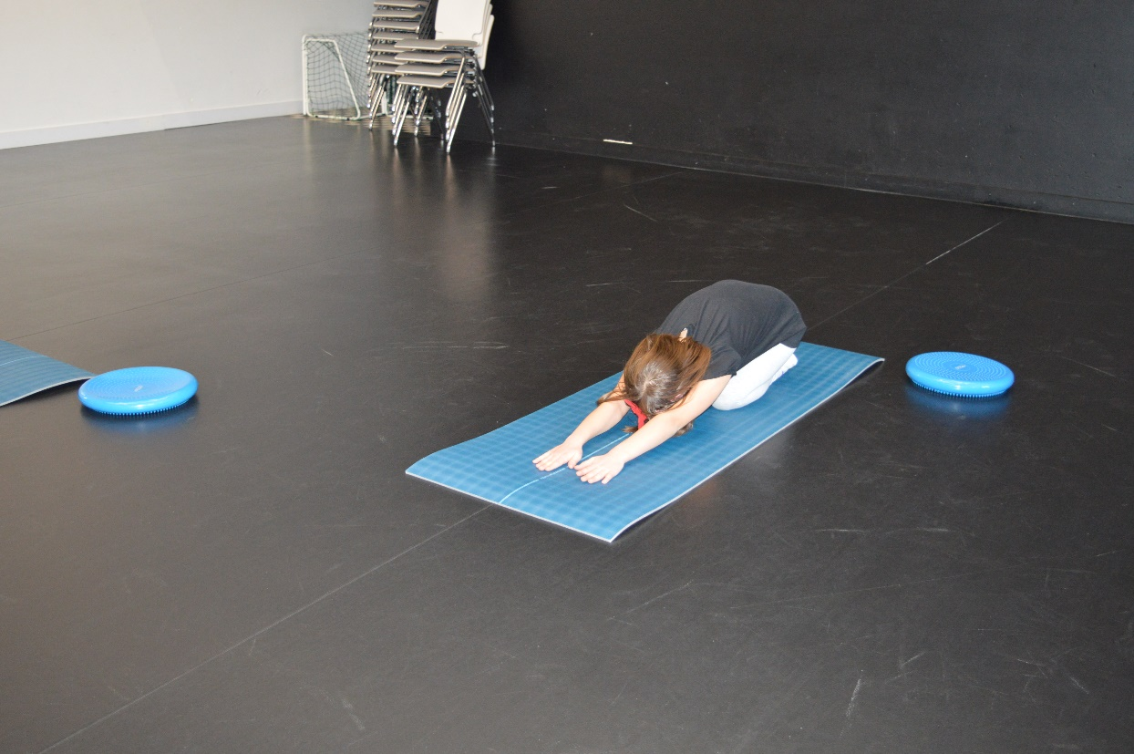

MOBILIZATION OF THE ISCHIO – SHIN GROUP

EXERCISE NO 5:

position- lying on your back, arms along the body, legs straight, lifting the leg, grabbing under the knee, pulling to the torso, straightening and bending in the knee state
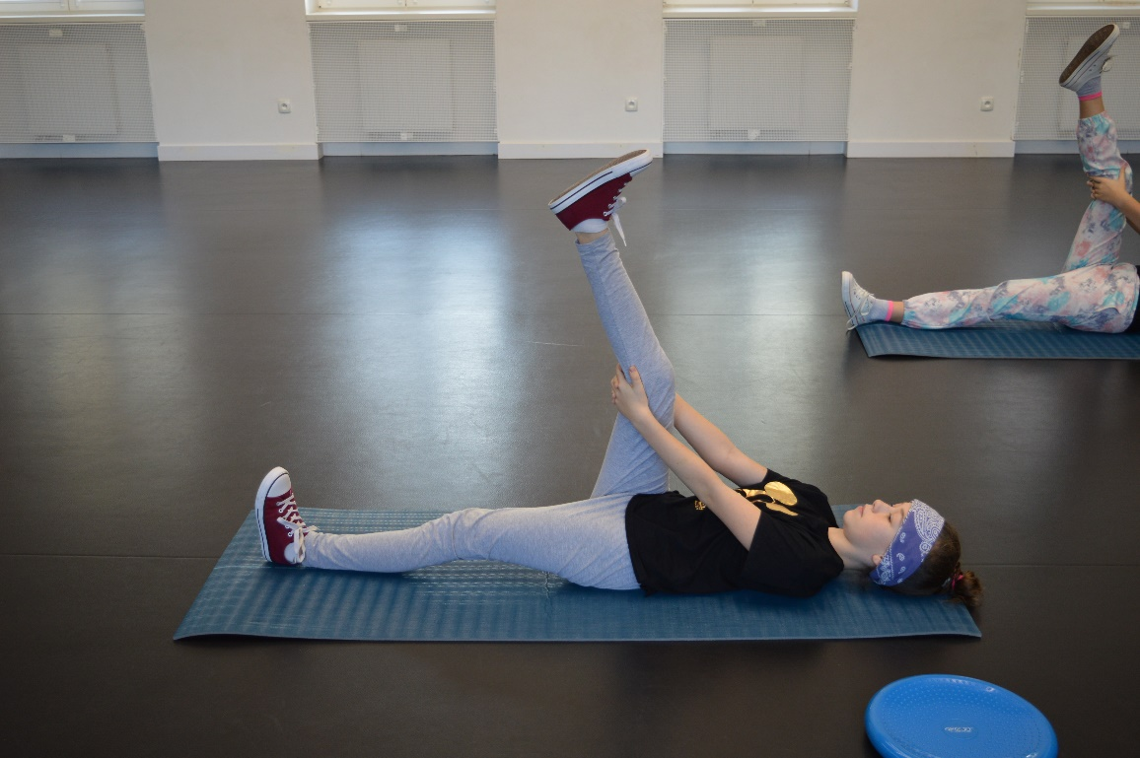
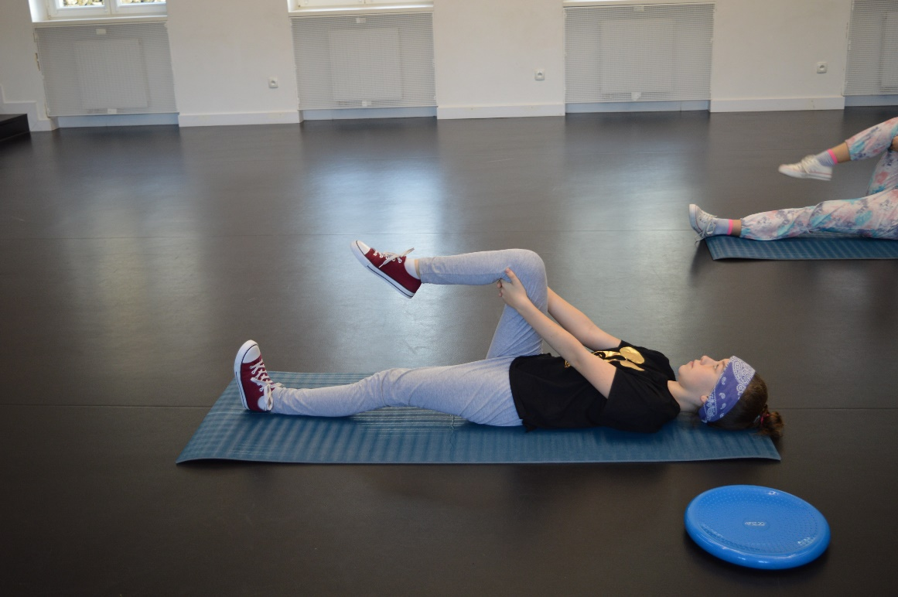

STRETCHING THE CHOKES

EXERCISE NO 6:
position - sit straight, a slight stretch, right leg straightened, left leg bent at the knee joint, the foot of the bent leg touches the right leg, change side; bends towards the right leg, left leg straight

MOBILIZATION OF HIP JOINTS

EXERCISE NO 7:
position - propped kneeling, lifting the torso up while touching a right hand to the left toes, change side
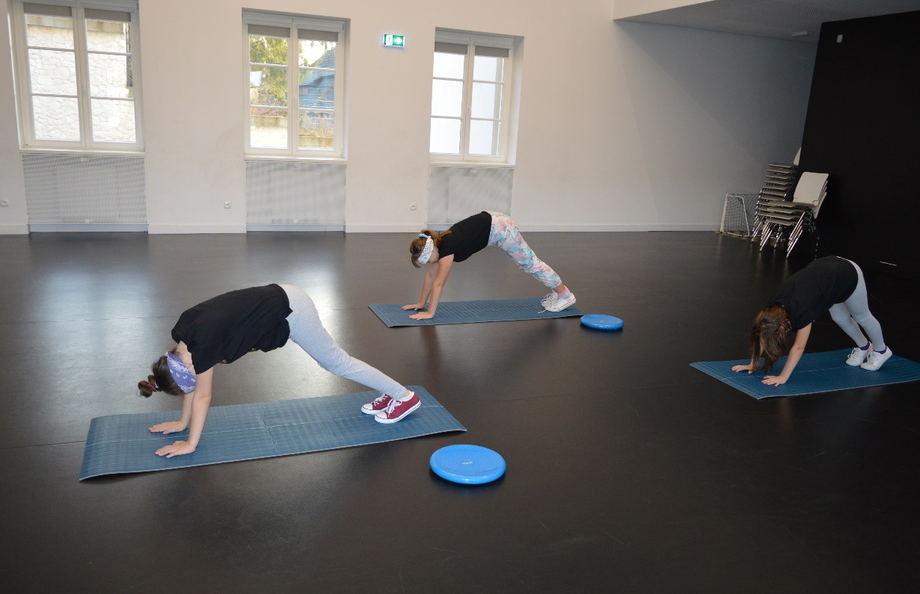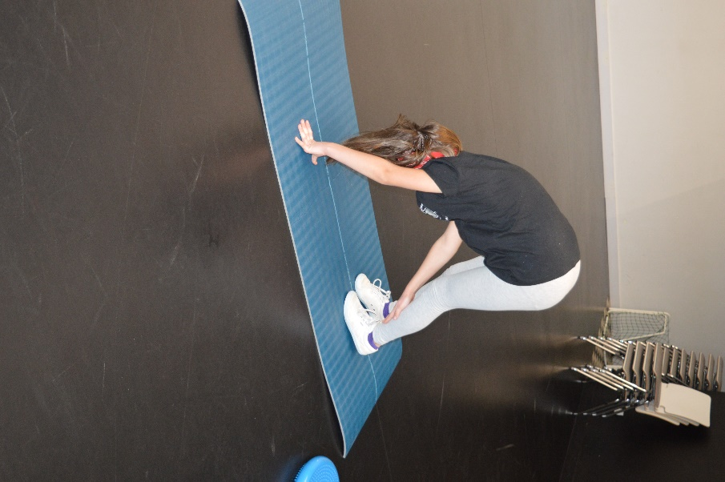

BREATHING EXERCISES
EXERCISE NO 8:
Standing position, hands to the side, folded hands on the chest;
inhale slowly, right hand to the side, slow exhalation, right hand back, change to the other side
EXERCISE NO 9:
Standing position – arms sideways up, inhale,
hands down, exhale

