OLD YARD GAMES
FROM POLAND

Gminny Zespół Szkół w Kazimierzu Dolnym

- HOPSCOTCH
Number of contestants:
At least 2 participants.

Necessary things:
A stick to draw on the ground or a chalk / drawing stone to draw on the pavement, a pebble for every player.

Game rules:
The participants draw the shape of the hopscotch.

The game's goal is toskillfully pass through the eight fields, that is throughout all eight years of primary school. Each child plays the game on their own account. The participants determine the order of participation in the game by means of counting nursery rhymes. The first player tries to throw a stone on the square with the number one. If he succeeds, he moves on the next square jumping on one foot (he jumps over the square one). Jumps on squares 4 and 5 as well as 7 and 8 are done with both legs at the same time. After jumping to squares 7 and 8, the player turns around and goes back the same way. Coming back, he picks up the stone while standing on the field earlier (in this case pick up the stone from field 1 while standing on field 2). Then the player throws a stone on the square with the number two and repeats the moves (he jumps over the square No. 2 and on the way back collects the pebble while standing on the square No. 3).
The game continues until the eighth field is reached. If a participant fails, for example, he steps a line or misses a stone in the field, the next player has the move. The first player to finish school (8 years) is the winner.

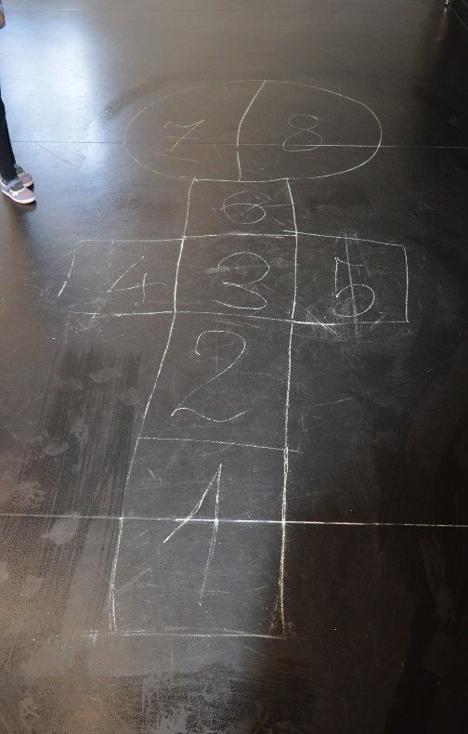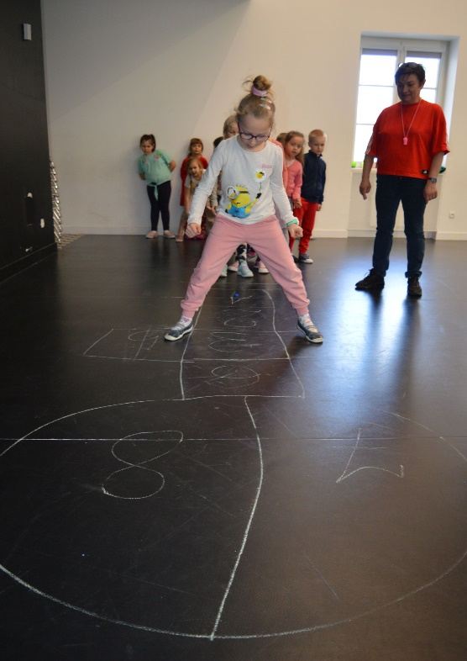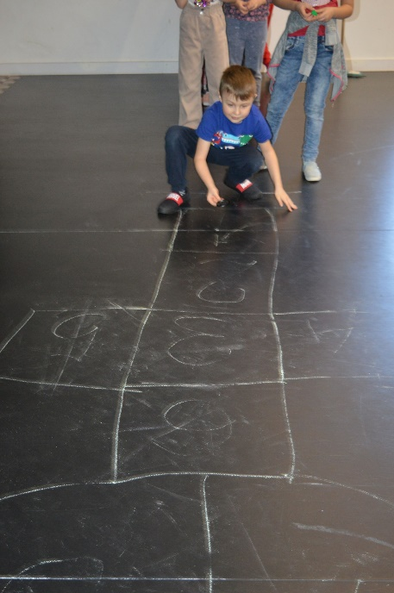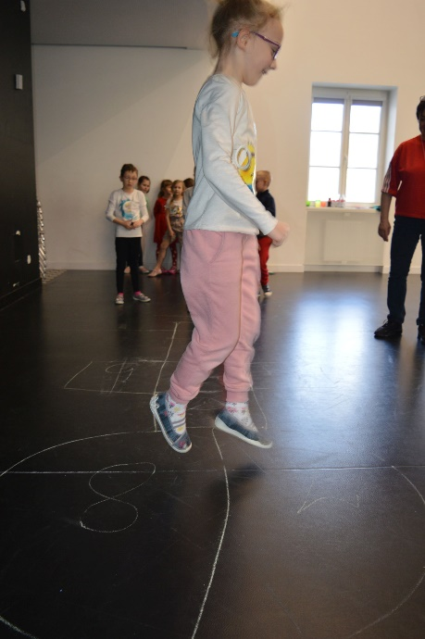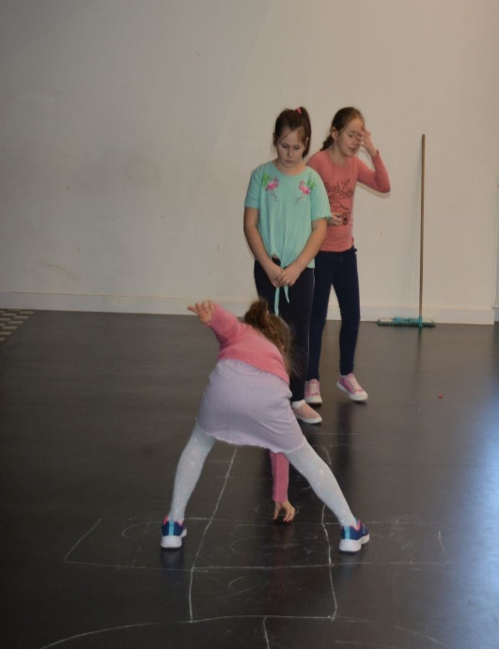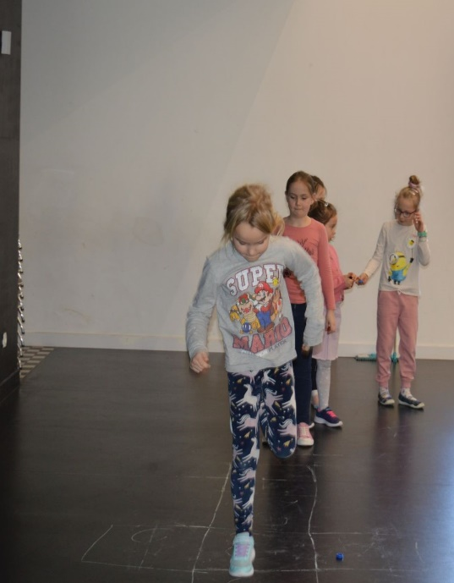
- COUNTRIES-CITIES

Number of contestants:
At least 4 participants, but not too many since after dividing the globe, the territories of the countries must be big enough for all the players to stand in their field (country or city).
Necessary things:
Beaten ground - one with clearly visible drawings written with a stick or asphalt. A stick large enough to be thrown easily, chalk to draw a globe and country borders, the text of any nursery counting rhyme.
Game rules:
The participants of the game draw a large circle on the ground (at least 3 m in diameter) and divide them into as many equal parts as there are participants (division by rays from the center of the circle). The radii of the circle are the borders of countries / cities. Each competitor takes the name of the selected country / city and enters it in its field. The game begins with a participant selected by means of a counting-out, and receives a stick.
The players stand in a circle on their countries and the person holding the stick in his hand says the following text aloud:
"I am starting a war against ..." (he mentions the name of the country that calls for a fight here) eg China !. At this point, he throws the stick as far forward as possible and starts running in the opposite direction. All participants run off, but only the opponent, China, must follow the stick. When he picks up the stick, he shouts: "STOP!" - then everyone has to stop. Now the participant who was first called to war (China) chooses another country to which he wants to start another war, saying: "I am starting war against Russia." Now he has to estimate his distance to the chosen opponent in order to get as close as possible and touch him with the stick.
The distance is determined by the steps:
- the so-called elephant (as large steps as possible),
- normal,
- feet (we put the heel of the right foot to the tip of the left toes, and so on).
The participant holding the stick must say loudly how many steps he will take (e.g. 10 elephant and 7 feet) and starts walking towards the opponent. During the course of the game, the rest of the players count steps with him, making sure that he doesn't cheat and constantly takes steps of one size. After all the steps have been taken, he stops. If he touches the opponent with a stick from this distance (before the game we determine whether the stick can be thrown or whether you have to stand on straight legs), he has the right to take part of his opponent's territory. If he fails to touch, the opponent gains his territory.
Taking territory:
This operation should be performed standing on your territory with both feet and leaning out as much as possible, with a stick, draw new borders of your country with a stick or with a chalk. After this action, the player from whom the ground was "taken" starts another game. Participants who have too little territory to stand on are excluded from the game.

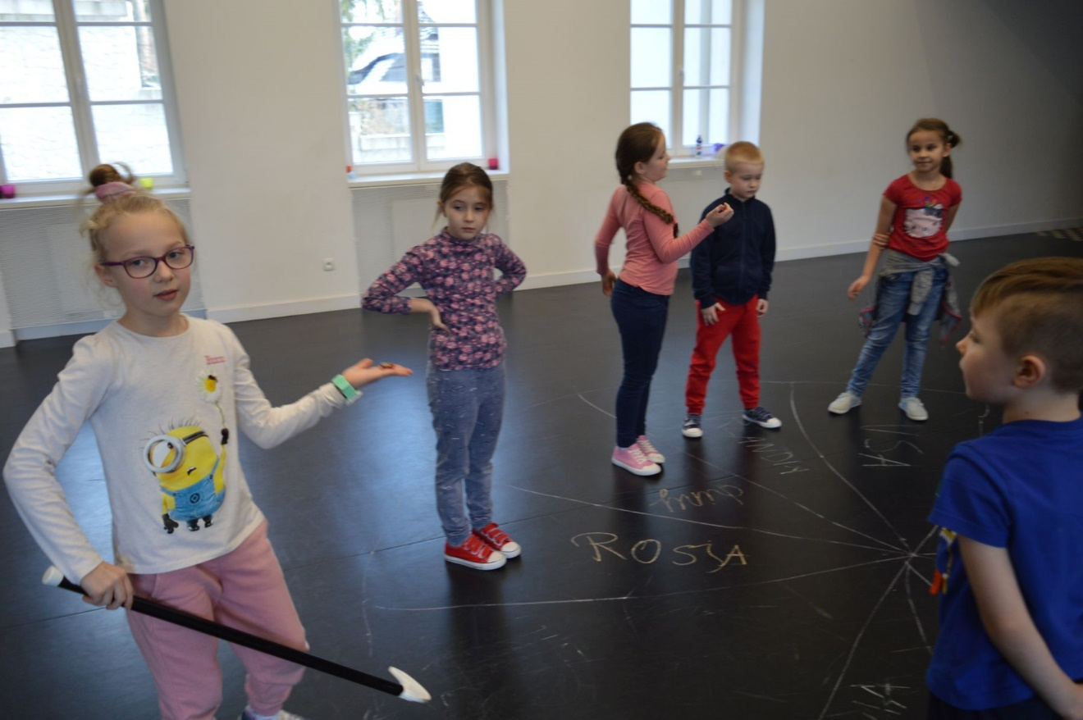
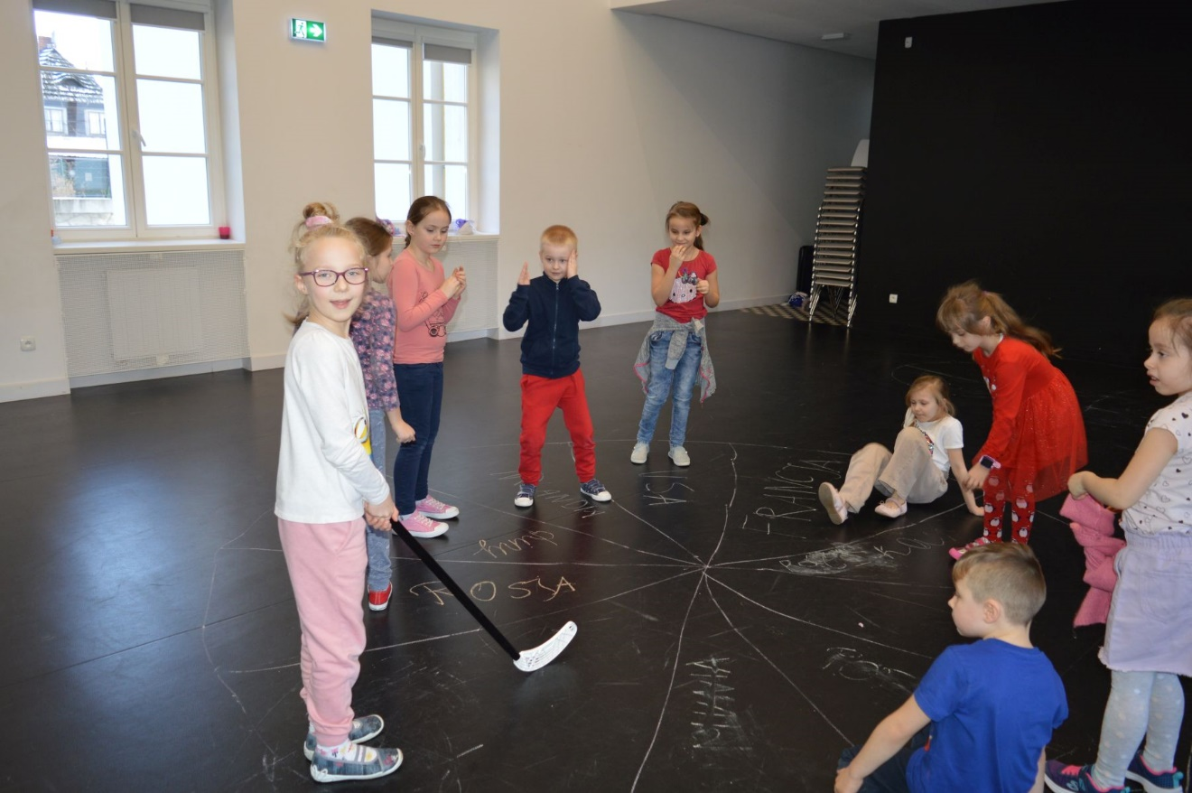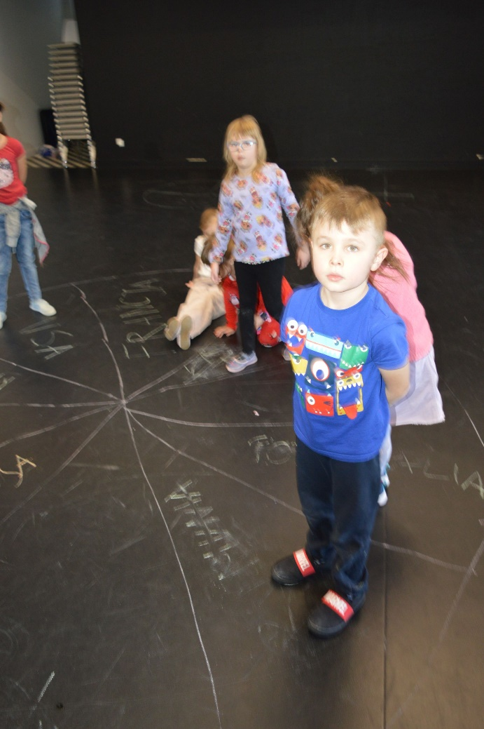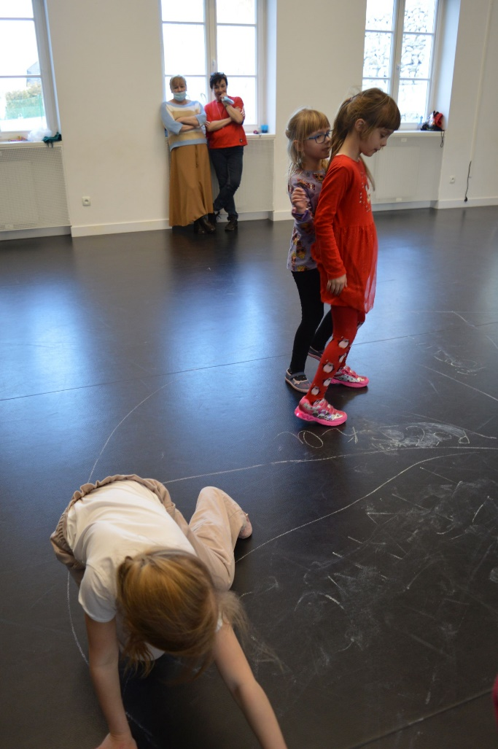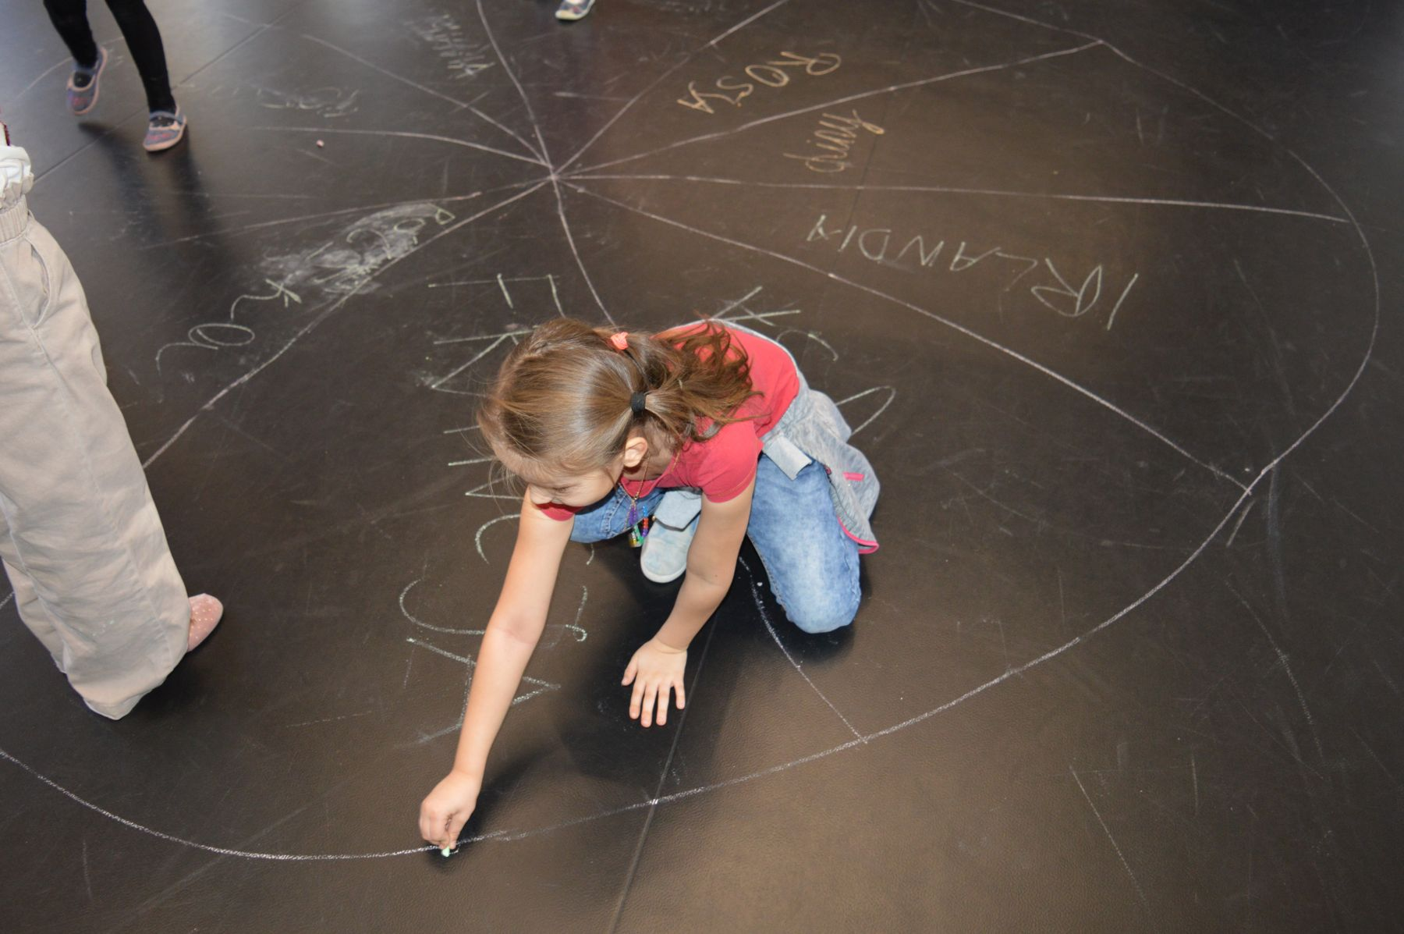

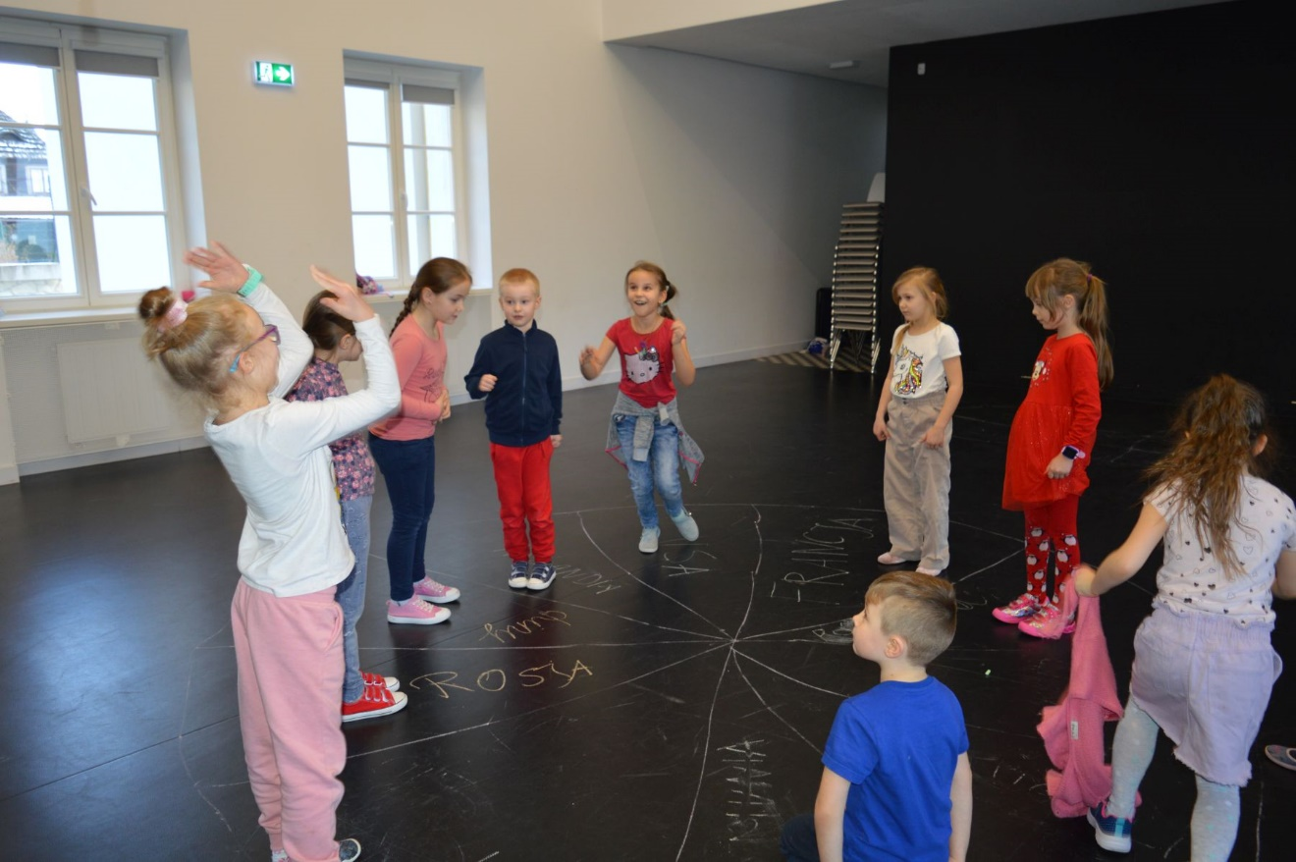

- CAPS
Number of contestants:
At least 2 players.
Necessary things:
A stick to draw on the ground or a chalk / stone to draw on the pavement, a bottle cap for each player.
In the 1980s, the game bore the very popular name of the so-called Peace Race. "Caps" were the races of bottle caps similar to the famous cycling races broadcast on television. Caps (cyclists) were specially prepared for the race - the interior was pasted with the flag of the country that the player represented. It was fixed with plasticine. Today, we can also decorate our caps and mark them, for example, by sticking flags, miniature pictures with favorite models of cars, motorcycles or images of sports idols.
Game rules:
On the ground we draw a track: with chalk or a stone on the pavement, with a stick on the beaten ground. The width of the track depends on the number of participants - the more players, the wider the track should be. We mark the start line and the finish line, and everything can "happen" between them, i.e. the track can turn, you can make sand embankments and launchers, obstacles made of branches, stones or water reservoirs (a hole in the ground protected with foil and filled with water, or a simple puddle ). We place the caps at the start, one next to the other, with the top side to the bottom and we move forward by flicking into the wavy side of the cap. We take turns and race to the finish line. Falling off the track means losing the turn. The player whose cap first crosses the finish line wins

